**Practical No. 6**

1. **Write a PHP program to-**
2. **Calculate length of string.**
3. **Count the number of words in string -without using string functions.**
4. **Write a simple PHP program to demonstrate use of various built-in string functions.**

**Code (Pg no. 57):**

<?php

function writeMessage(){

    echo "This is an Example of Functions without parameters";

}

writeMessage();

?>

**Output:**

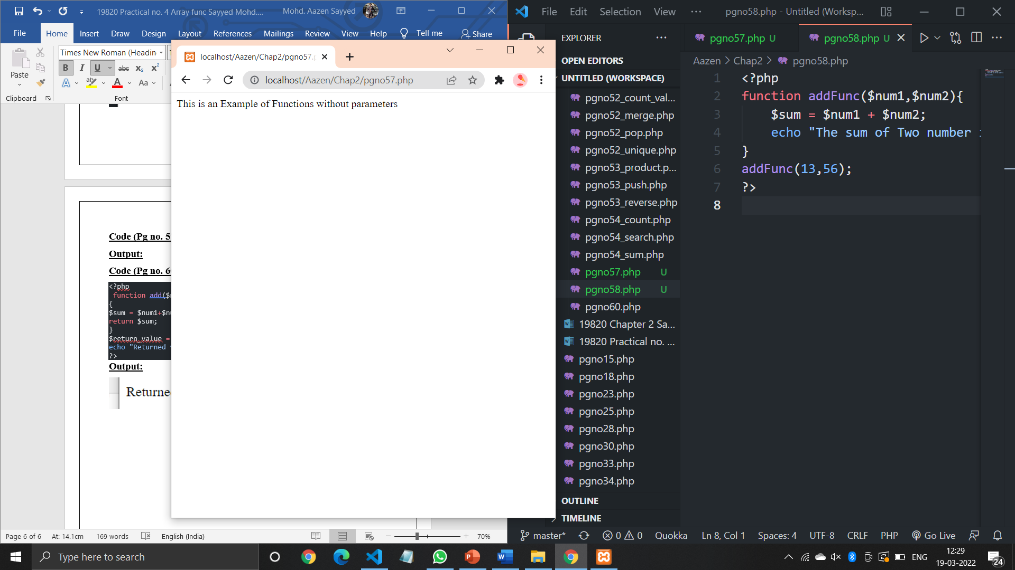

**Code (Pg no. 58):**

<?php

function addFunc($num1,$num2){

    $sum = $num1 + $num2;

    echo "The sum of Two number is : $sum";

}

addFunc(17,96);

?>

**Output:**

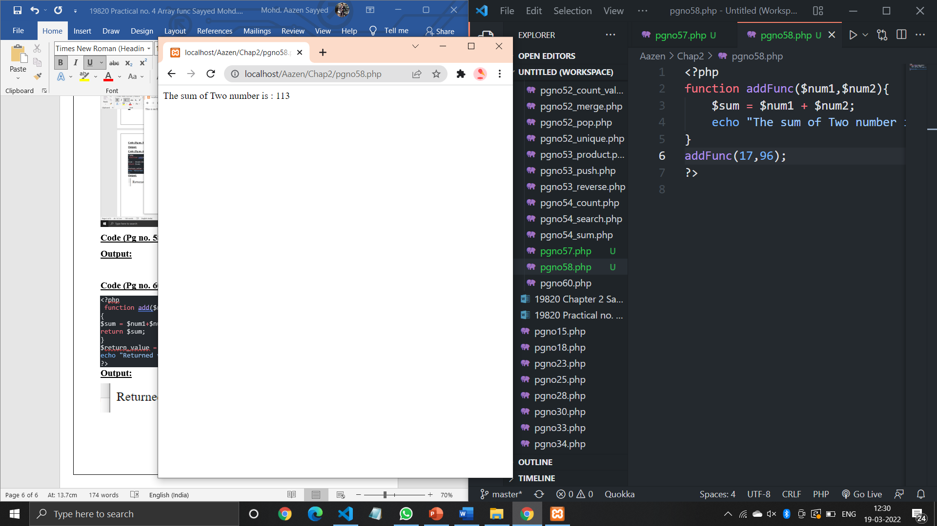

**Code (Pg no. 60):**

<?php

 function add($num1, $num2)

{

$sum = $num1+$num2;

return $sum;

}

$return_value = add(50, 20);

echo "Returned value from the function: $return_value";

?>

**Output:**

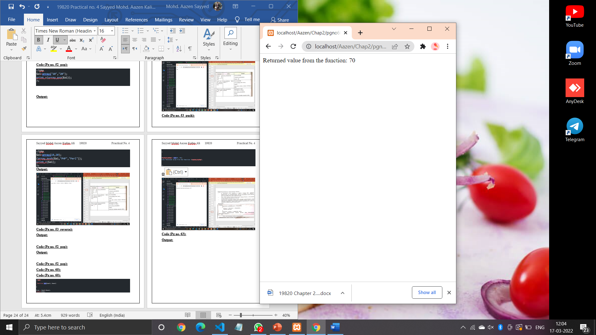

**Code (Pg no. 63):**

<?php

    function simple(){

        echo "In simple()<br />\n";

    }

    function data($arg = " ")

    {

        echo "In data(); argument was '$arg'.<br>\n";

    }

    $func = 'simple';

    $func();

    $func = 'data';

    $func('test');

    ?>

**Output:**

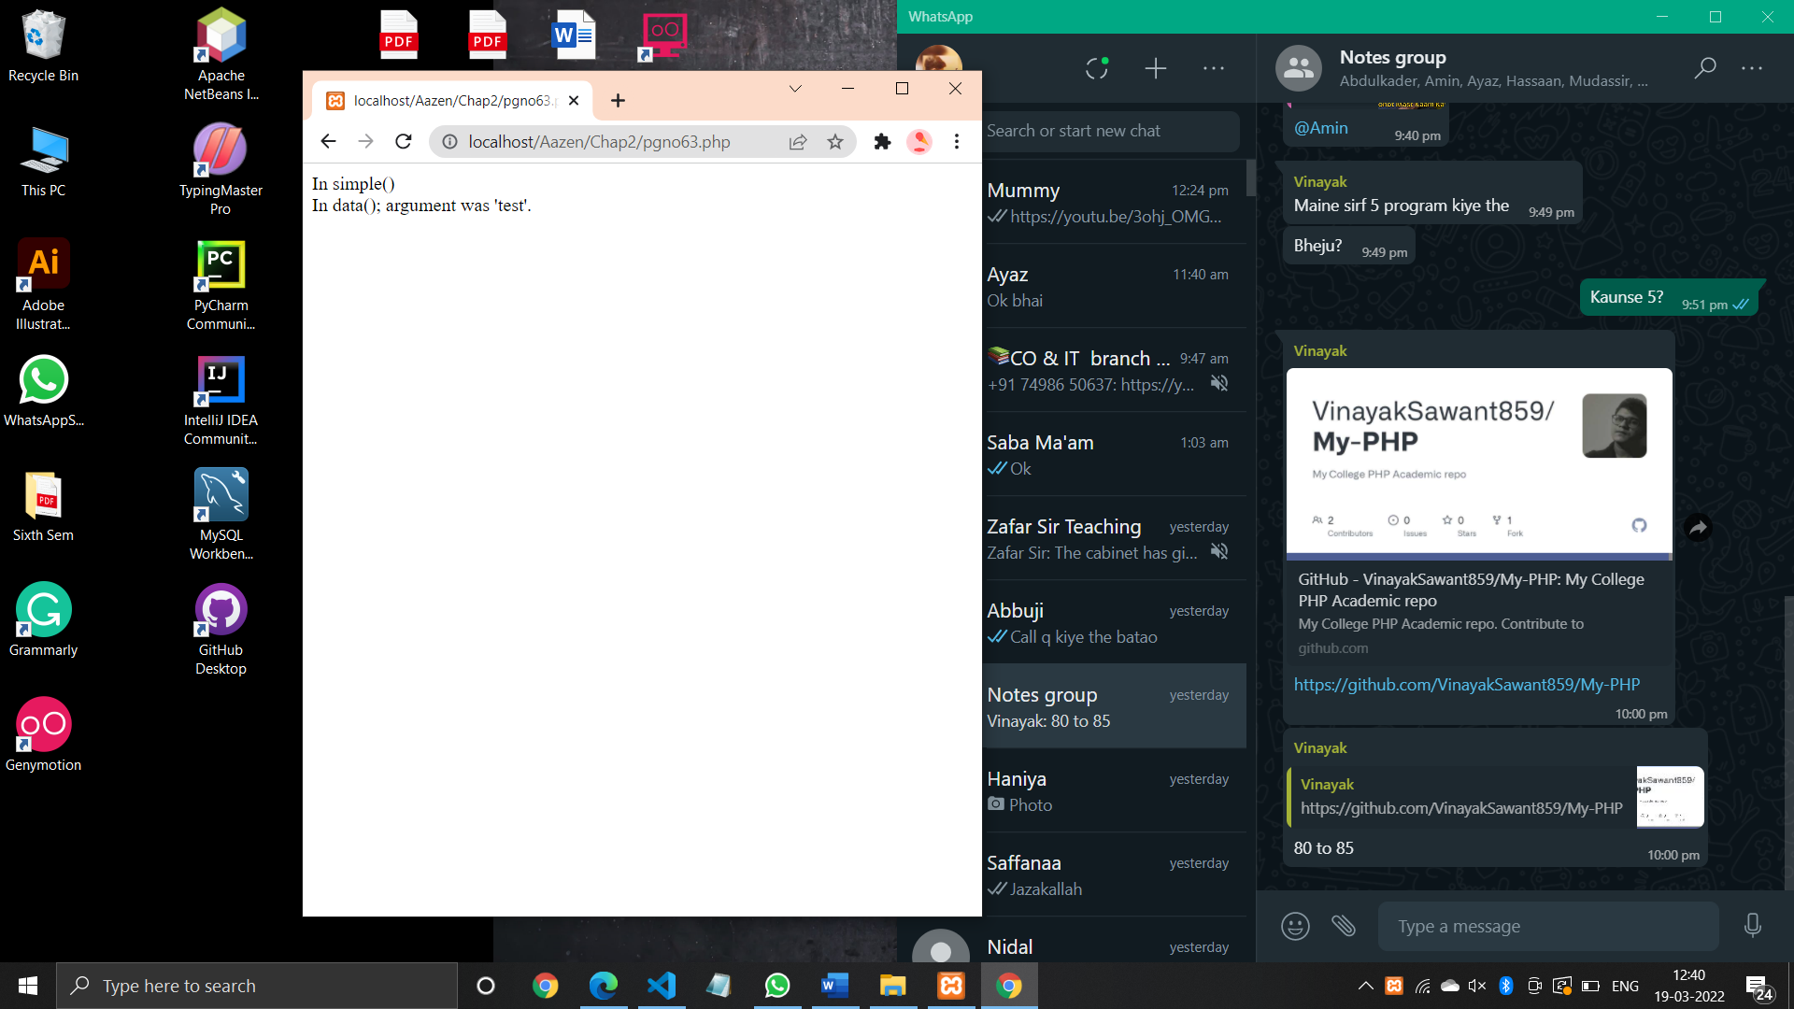

**Code (Pg no. 64):**

<?php

    $function = function(){

        echo 'Information Technology';

    };

    if(is_callable($function))

    {

      echo "It is Function";

    }

    else

    {

        echo "It is not Function";

    }

    $var = "IF";

    echo "<br>";

    if(is_callable($var))

    {

        echo "It is function";

    }

    else

    {

        echo "It is not function";

    }

    ?>

**Output:**

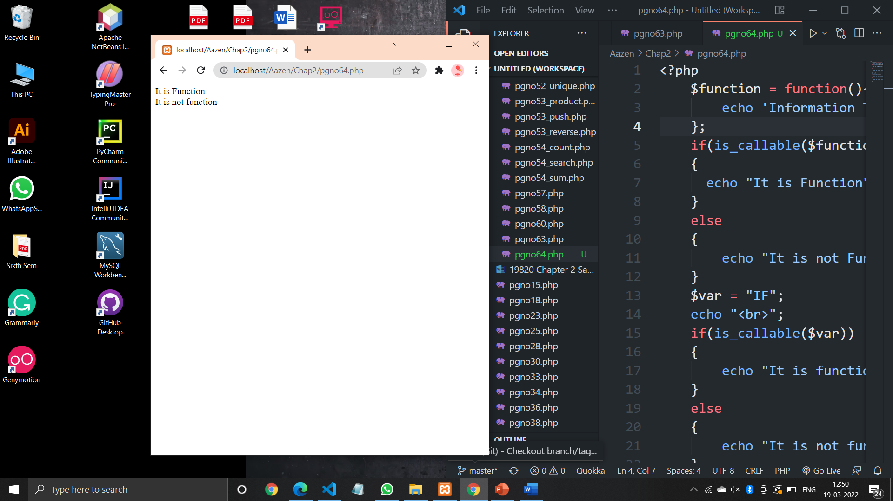

**Code (Pg no.67):**

<?php

    $str = "hello world!";

    $lambda = create_function('$match', 'return "friend!";');

    $str = preg_replace_callback('/world/',$lambda,$str);

    echo $str;

    ?>

**Output:**

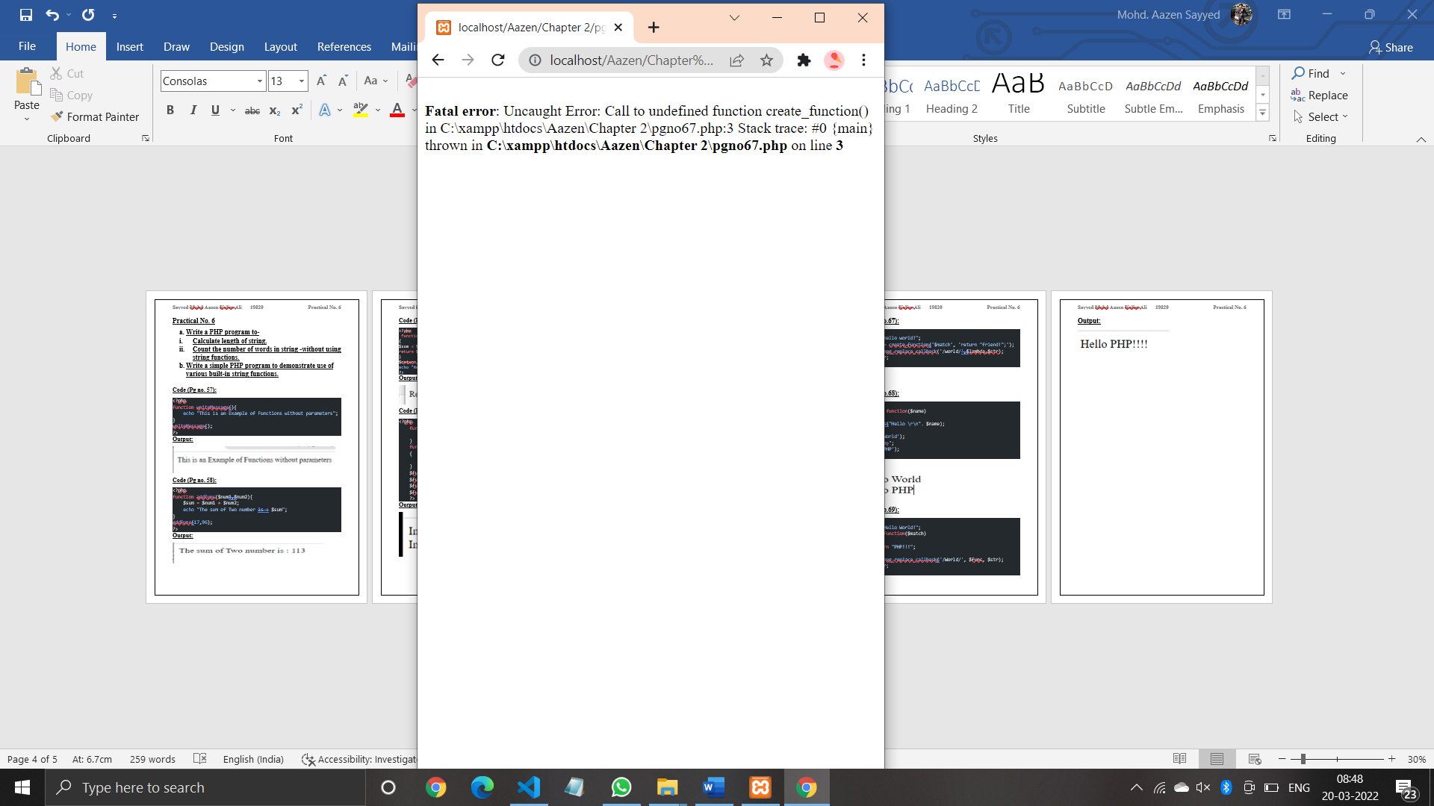

**Code (Pg no.68):**

<?php

    $greet = function($name)

    {

        print("Hello \r\n". $name);

    };

    $greet('World');

    echo "<br>";

    $greet('PHP');

    ?>

**Output:**

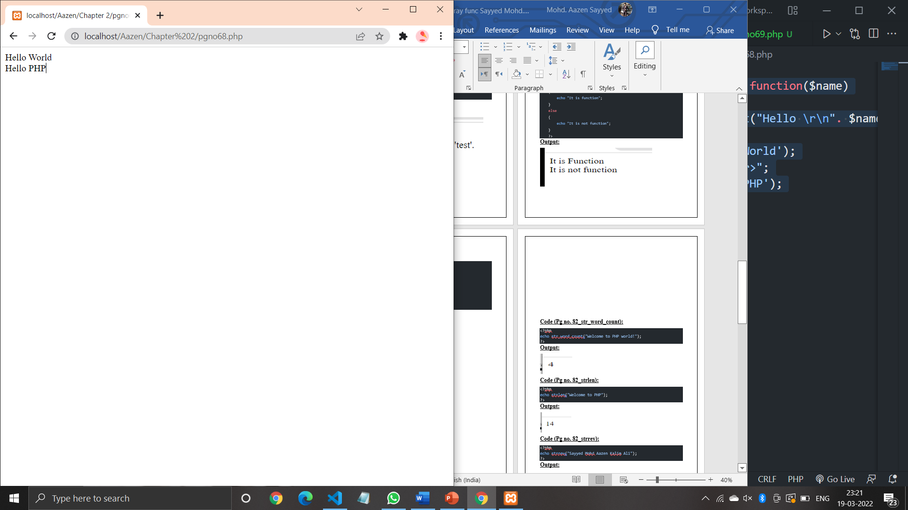

**Code (Pg no.69):**

<?php

    $str = "Hello World!";

    $func = function($match)

    {

        return "PHP!!!";

    };

    $str = preg_replace_callback('/World/', $func, $str);

    echo $str;

    ?>

**Output:**

